TRIBOLOGICAL PROBLEMS AND DIRECTIONS OF SOLUTIONS Use 12 pt spacing before and 12 pt spacing after paragraph {TITLE, all caps 14 pt}
J. Jonaitis*, V. Heinu** {Author, italic, bold 12 pt}
*Institute of Mechanical Engineering, Vytautas Magnus University, Lithuania
**Department of Materials Engineering, Tallinn University of Technology, Estonia {Institution, normal 11 pt}
Abstract: the article reviews wood as a constructional material – its chemical composition and mechanical properties... The maximum length of abstract is 10 lines. Use 12 pt spacing before and 6 pt spacing after paragraph {Abstract, normal, 10 pt}
Keywords: wear, friction... The maximum length of Keywords is 1 line. {Keywords, normal 10 pt}
1. INTRODUCTION (Use 18 pt spacing before and 6 pt spacing after paragraph) {CHAPTER, All caps, bold, 12 pt}
Recommended structure of scientific paper: Abstract, Introduction, Experimental, Results and Discussion, Conclusions, Acknowledgements, References. {main text, normal, 11 pt}
Papers must be written according to the layout and instructions given in the document. We accept papers only written in English on disc (as Word file) to prepare your manuscript. The pages should be not numbered. {main text, normal, 11 pt}
2. LAYOUT AND FORMATTING (Use 18 pt spacing before and 6 pt spacing after paragraph) {CHAPTER, All caps, bold, 12 pt}
The maximum length of the title is 2 lines. Try to avoid acronyms and abbreviations in the title. The title of the manuscript, full names, organisations and addresses of the authors should be centred.
Please do not change this example – the content and adjustment of Header, Footer, Page Number.
Leave one line space above all headings. Use 6 pt spacing after paragraph. The text of manuscript must be prepared in one column with single line spacing. Please use Times New Roman font! The font sizes to be used in the different parts of the manuscript are given in Table 1. {main text, normal, 11 pt}
Table 1. Font sizes to be used in the manuscript. {Table text, normal, 10 pt}
 | font size [points] | Font style |  | font size [points] | Font style
Title | 14 | All caps, bold | Main text | 11 | Normal
Author(s) | 12 | Italic, bold | Table and figure captions | 10 | Normal
Organisation | 11 | Normal | Formulas | 12
Abstract and keywords | 10 | Italic | References, contact point | 10 | Normal
Headings | 12 | All caps, bold | Table text | 10 | Normal
Use two levels of numbered headings at most. (first line of text after table - Use 6 pt spacing before and 6 pt spacing after paragraph) {main text, normal, 11 pt}
The minimum length of the Paper is 5 pages and the maximum length is 8 pages. The text should be clear typed on one side of the A4 sheet. {main text, normal, 11 pt}
Please use 25 mm left, right, top and bottom margins on the A4 (21.0×29.7 cm) sheet.
Example of text: There are 427 mln. m³ of wood growing in the Lithuanian forests. On average 2.9 mln m³ are used for production annually [1, 2]. Regardless to the sort of tree, the organic mass of completely dry wood contains 49–50% carbon, 43–44% oxygen, approx. 6% hydrogen and 0.1–0.3% nitrogen. The wood density may reach 0.51–1.09 g/cm³ [3, 4]. {main text, normal 11 pt}
3. FIGURES, TABLES AND EQUATIONS (Use 18 pt spacing before and 6 pt spacing after paragraph) {CHAPTER, All caps, bold, 12 pt}
Figures and tables should be referred to in the text and they should be placed on the same page, where they have been first discussed. {main text, normal, 11 pt}

3.1. Figures
Figure 1 and 2 gives the limits, which must be followed in order to get a good result for your paper in the proceedings. {main text, normal, 11 pt}
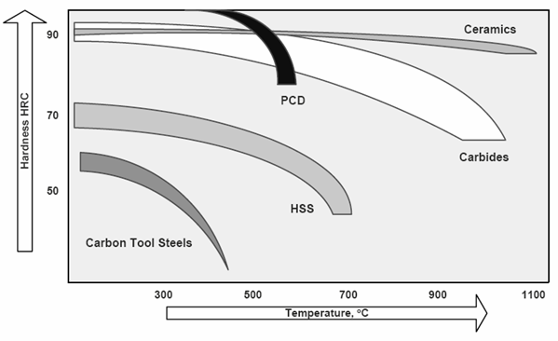
Figure 1. Influence of temperature on hardness of tool materials [7] The maximum size is 15 × 10 cm (width × height); the minimum line width is 0.3 mm; the minimum size of the text in figures is 10 points) {Table and figure captions, normal, 10 pt; Align text left}
Figures must be readable: text strings included should be 10 points minimum.
Figures have to be numbered and must have captions under the figures. Use empty line between figures, captions and texts. The figures must be included in the data form. {main text, normal, 11 pt}
a 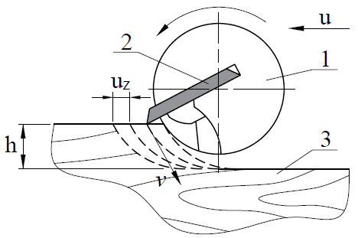 | b 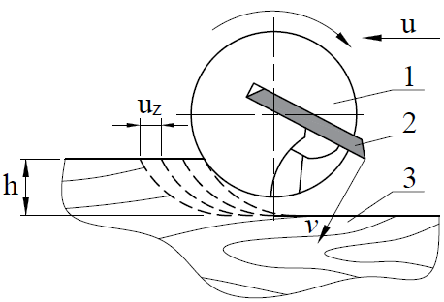
Figure 2. Milling types: a) the tool rotates against to feed direction; b) the tool rotates in the feed direction:
1 – tool; 2 – cutter; 3 – workpiece; v – linear speed; u – feed direction; h – thickness of cut layer; u_{z} – feed per one cutter [8] The minimum printable line is 0.3 mm. the minimum size of the text in figures is 10 points. {Align text left, normal, 10 pt}

3.2. Tables
Tables have to be numbered and must have captions above the tables (see Table 1).

3.3. Equations
Equations should be placed on separate lines and numbered. They should be indent by 5 mm, and the numbers should be brackets and right aligned. See the example (1). {main text, normal, 11 pt}
Hourly productivity P ($kg h^{-1}$) of surfacing is a calculated:
$P=0.0016M η,$ (1)
Where: M – mass of one electrode, kg; η – deposition coefficient of electrode.
The strength _{nп} (N m⁻²) of adhesion bonds on the cut is determined from the relation:
$τ_{nn}=\frac{3}{4}∙\frac{F_{exp}}{π}∙\frac{R_{exp}}{r_{ind}^{3}},$ (2)
Where: F_{exp} is the circumferential force (N) on the disc, rotating the indenter; R_{exp} is the radius (m) of the disc in which the indenter is fixed; r_{ind} is the radius (m) of the indent on the samples.

3.4. Conclusions
The number of conclusions is not limited, but should not be excessive when disclosing the same research results. {main text, normal, 11 pt}

3.5. References
Examples of bibliographic descriptions of literature references were used are given below. Do not use automatic numbering for submit version of article. {main text, normal, 11 pt}
REFERENCES
[1] Writer A. Book name. Cliffhanger. New York. 1997. 345 p.
[2] Csanady E. And Magoss E. Mechanics of wood machining. Chapter 7. Tool Wear. Springer-Verlag Berlin Heidelberg, 2013. 199.
[3] Author S., More T. Title of the paper. Journal Name 13, 3 (1993) 11–18.
[4] Winkelmann H., Badisch E., Roy M., Danninger H. Corrosion mechanisms in wood industry, especially caused by tanins. Materials and Corrosion 60, 1 (2009) 40–48.
[5] Scientist S. Title of the paper. Proc. of the int. conf. “Tribology of machines”. TU Vienna. 02–04.04.2000. Vienna. Austria. 2000. 113–127.
[6] Vernickaite E., Antar Z., Nicolenco A. et other. Tribological and corrosion properties of iron-based alloys. The 8th Int. Conf. BALTTRIB'2015, Aleksandras Stulginskis university, 26–27.11.2015, Kaunas, Lithuania. 2015. 162–169.
[7] Fuks, I.G., Dobavki k plastichnym smazkam (Additives to Plastic Greases), Moscow: Khimiya (Chemistry), 1989. 248 p. (in Russian).
[8] Vinogradov V.N., Sorokin G.M. Iznosostoykost' staley i splavov [Wear resistance of steels and alloys], Moscow: Neft' i gaz (Оil and gas), 1994, 417 p. (in Russian).

Author for contacts: Prof. dr. Victor Heinu {normal, 10 pt} E–mail: abc@cba.com

